**Program Documentation**

1. **Introduction**

In this project, I wrote a Star Wars theme small game named *Star Wars Duel* with MIPS assembly language on MARS Simulator. The project is a strategic game. There are two characters in this game: Yoda and Darth Vader. The player could choose either one of them, and the computer will pick the other one.

Initially, both characters will have 100 points of HP, 3 great hit slots and 3 heal slots. Both characters can have unlimited times of ordinary strike operations, plus 3 great hit (the force) operations and 3 heal operations.

For each character, the ordinary strike will cause HP loss (ranging from 1 to 10) on the opposite character, the great hit operation will cause heavier HP loss (ranging from 11 to 20) on the opposite character, and the heal operation will cause HP increase (ranging from 1 to 10) on the character.

The goal of the game is for the player to use the character he/she picks to defeat the computer’s character. In order to defeat the computer’s character, the player must cause the computer’s character’s HP to reach to 0 or below, meanwhile maintaining his/her character’s HP above 0.

Each character takes one operation at a time, when one character makes a valid operation, unless the opposite character’s HP reaches 0 or below, that character will always be the one who makes the next operation. The player could make an operation decision by will, while the computer’s operation is determined by randomness.

There is no restriction on the usage of ordinary strikes, but if the player attempts to use great hit or heal operations with 0 slots left, the program will ask the user to choose another operation. The computer will not violate the overuse of great hit or heal operation either.

If either character’s HP drops to 0 or below, a winner will be determined. Based on which character wins and which character the player selected, different ending music (*Imperial March* or *New Hope*) and outcome reports will be provided to the player before the program automatically ends. The player could also end the program anytime during the game by clicking the “Cancel” button in the dialog boxes.

1. **Instructions:**
2. Open the “Star_Wars_Duel.asm” file from MARS, then click “Assemble” button (or press F3)

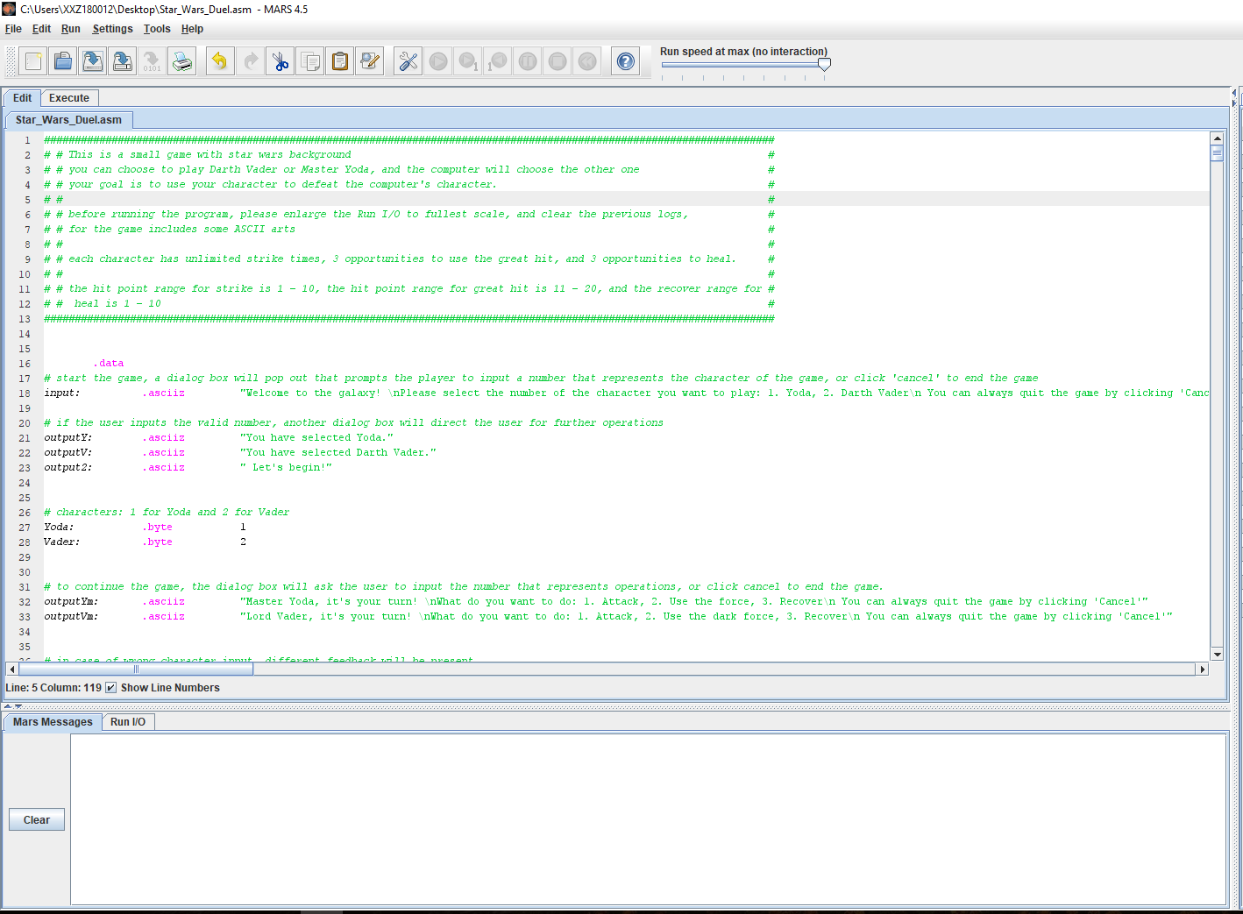

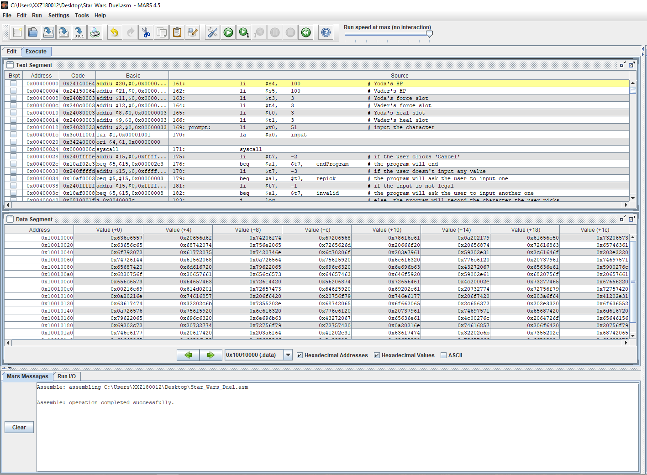

1. After assembly, enlarge the I/O console to fullest scale and clear all previous records, the click the “Run” button (or press F5).

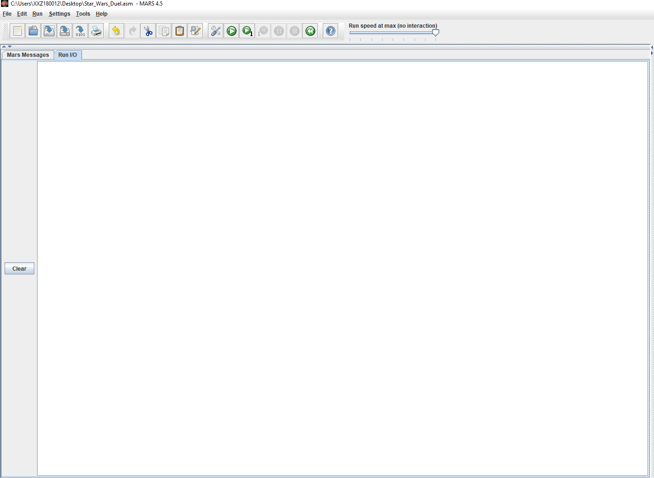

1. A dialog box will be prompted and ask the player to select a character, input 1 to select Yoda or 2 to select Darth Vader.

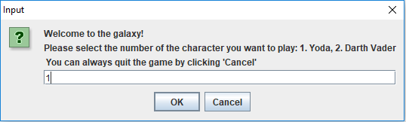

1. After making a selection, the program will inform the player that the game has started, and another dialog will ask the player to make operations.

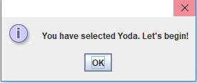

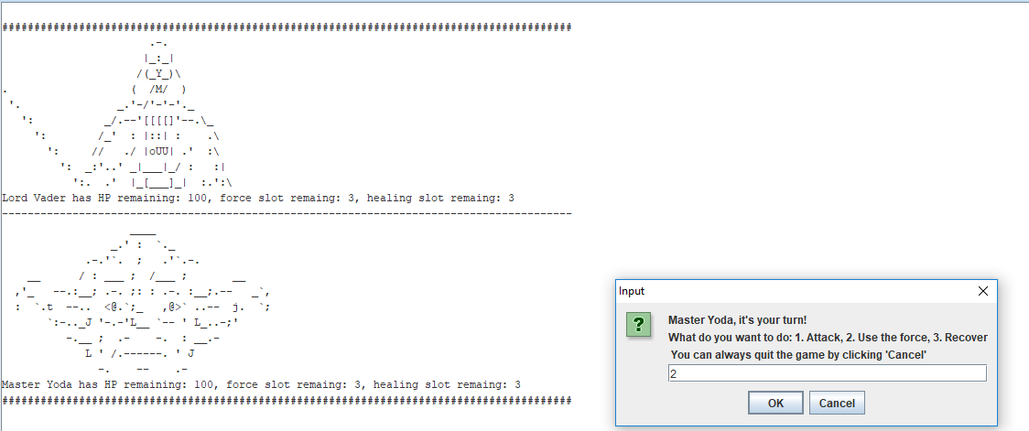

1. Based on your selection, the program will print the operations each character makes and the status of them

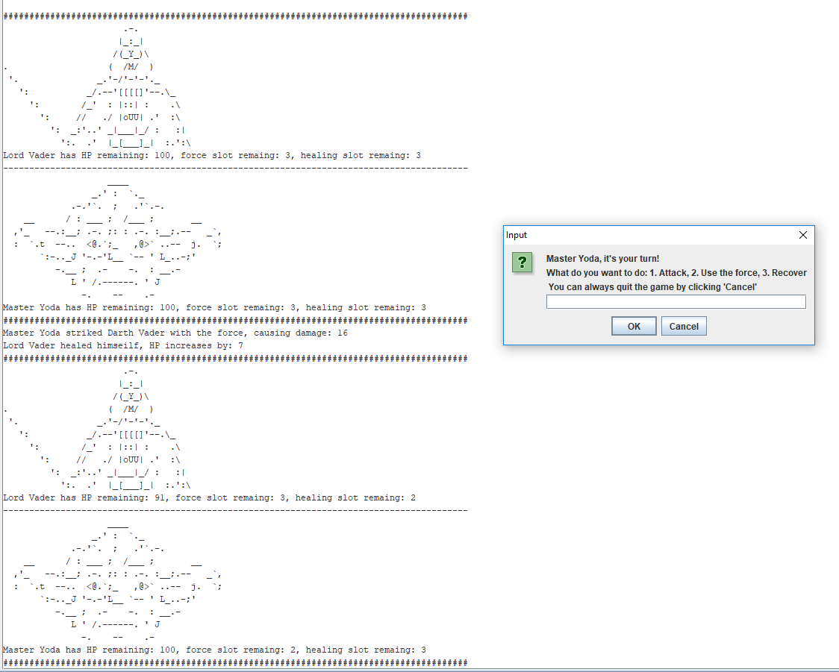

1. If the player select the great hit or heal while the slot remaining is 0, the program will ask the player to select another operation.

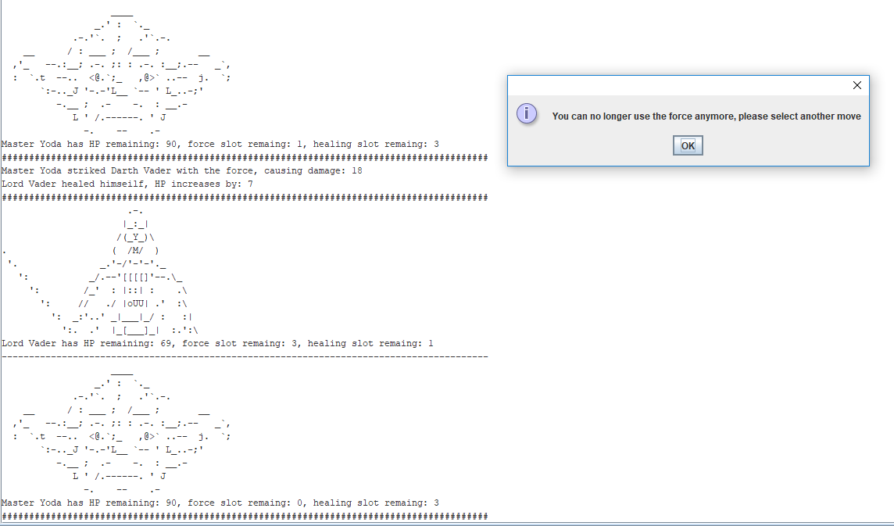

1. When either character’s HP reaches 0 or below, the program will play a piece of music, inform the player whether he/she won or lost, then end the program automatically.

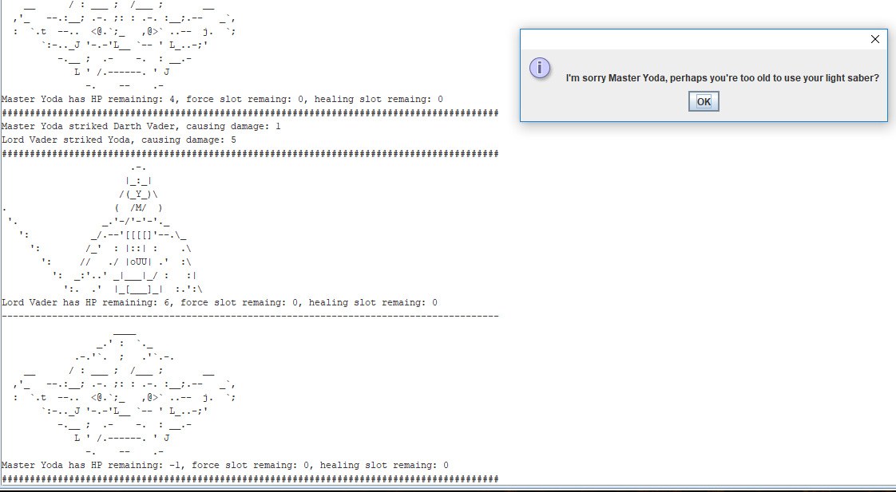

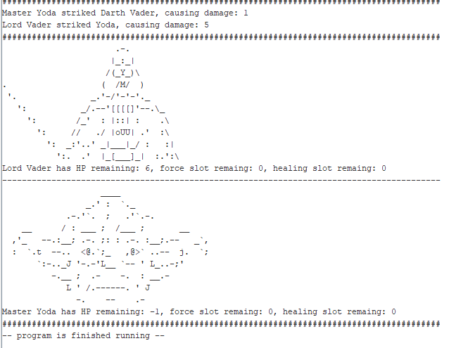

1. **Notice**
2. Before started, make sure that the program’s asm file be run on MARS V4.5 (Download link: http://courses.missouristate.edu/KenVollmar/mars/MARS_4_5_Aug2014/Mars4_5.jar). Please also make sure that the computer has Java SDK installed and could play sounds.
3. During the game, the player could always end the program manually by clicking “Cancel” on the dialog box.
4. After assembly, please enlarge the I/O console to fullest scale and erase all previous contents, so that the combat record could be viewed with optimum effects.